Mini Racer

Subject:Electricity, Circuits, Newton’s Laws of Motion  Related Subjects:Physics, Mechanical Engineering | Grade Level(s):  Length of Lesson: | Type: Inquiry / Design / Project  Keywords:

Lesson Overview
Many factors play into a car’s movement including the design of the wheels, weight, power supply and friction. In this mini racer, the batteries and wires must create a closed circuit in order for electricity to flow around the circuit. The “wheels” and body of the racer must also be designed to reduce the friction and weight of the racer.

Lesson Focus
Students will design and build a mini racer with the given materials.

Lesson Objective(s) | - Students will design and build a mini racer with given materials to be launched for farthest distance in a straight line from the launching point.  - Students will gain a greater understanding of mechanical engineering, circuits and the physics behind race cars.

Lesson Timing

5 minutes | Introduce the Lesson
30 minutes | ...

Materials | Per Group:  Chassis  - 4 craft sticks  Rear and Front Suspensions  - 1 cork or 4 wheels  - 2 plastic straws  - 1 Wooden Skewer  Circuit  - 1 2-AA battery holder  - 1 - 1.5 V Motor  - 1 Small light bulb with blue wires  - 1 red LED  - 1 Brass Fastener  General:  - Hot Glue Gun and glue sticks  - Black Wire  - Red Wire  - Wire Strippers  - X-acto Knives
Instructor Prep | - Step 1
Related Resources | - List related lessons/ppts etc available from USC or outside, trusted orgs

Lesson Plan

Introduction
Introduce students to the learning goals and make connections to past and present learning experiences. Stimulate interest and prompt students to identify their own questions about the topic. This can link the lesson to real world examples, introduce associated STEM careers, and assess their prior knowledge on the topic.

- Step 1

Procedure
Step 1: Design and Build the Chassis
Decide on the shape of the chassis by evaluating the materials given to your group in order to build a racer that will travel the furthest distance in a straight line. Your group does not need to use all of the given materials for the chassis. The chassis of the racer has to be:
- Sufficiently stable to carry the weight of the battery holder.
- Sufficiently sturdy to withstand the torque of the motor.
Step 2: Design and Build the Rear and Front Suspensions
The rear and front suspensions must be stable and the wheels should avoid as much friction as possible with the axles. The axles must be long enough to spin freely when connected to the chassis.
Your group does not need to use all of the given materials for the rear and front suspensions. Note: the wooden skewer can be used as the axle; in order for the axle to turn, insert wooden skewer into straw.
Step 3: Creating the Circuit
The series circuit is formed when the battery holder, motor, white light bulb and red LED are connected together by wire. Incorporate circuit onto chassis and suspensions in order to determine the length of each wire required. The picture below outlines how to wire the circuit:
Notes:
- On the front lead of motor, attach the red wire from battery holder, blue wire from white light bulb AND an additional 5 inch red wire; attach the other end of this additional red wire to LONGER leg of red LED.
- On the back lead of motor, attach an additional 5 inch black wire; attach other end of this additional black wire to SHORTER leg of red LED AND other blue wire of the white light bulb.
- The brass fastener can be used as the “on/off switch”. Attach black wire from battery holder to the brass fastener to test circuit.
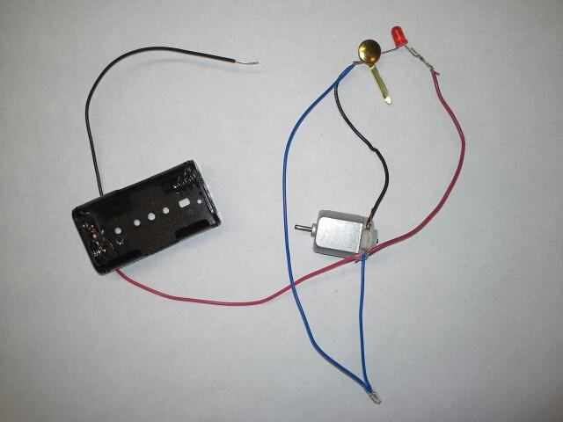

Wrap-up
End the lesson with some final discussions about what students designed/discovered. Connect their activity back to the focus question/problem, real world examples, and STEM careers.

Also include notes about any special cleanup considerations

Lesson Background for Teachers

Suggested Real-World STEM Connections
- List possible related Role Models in STEM (with details and links to more reading). Give suggestions for examples of scientists/engineers who are from underrepresented groups in STEM in related careers.
- List related real-world engineering problems and examples

Lesson Variations and Options
Include descriptions of alternative methods or ways to present things.

Explanation
Describe the background concepts and explanations behind the lesson. This can be more in depth than a teacher/instructor would actually share with students.

Key Concepts and Vocabulary
- Word 1: Grade Appropriate Definition
- Word 2: Grade Appropriate Definition

Safety Notes
- Safety instruction

